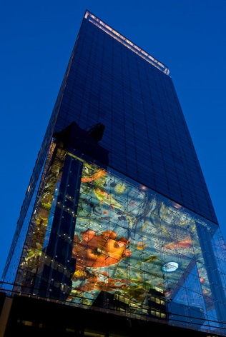
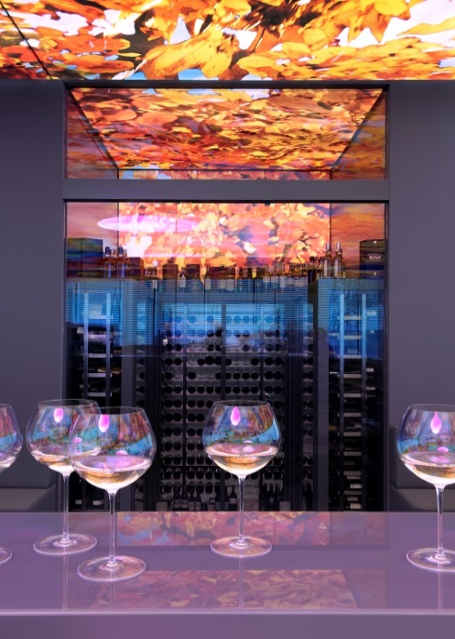
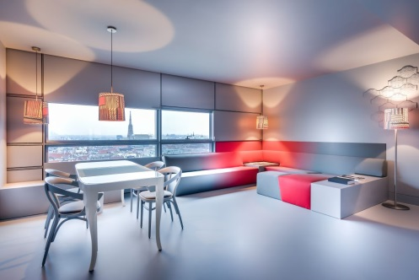
THE LIVING DREAMSCAPE
ROOM RESERVATION FORM
“ISAPS 2021”
09th of September to 13th of September 2021
SO, who is coming?
Family Name Company Name
First Name Country
E-Mail Business/Mobil
SO, real talk!
☐ EUR 290,00 single occupancy
☐ EUR 320,00 double occupancy
all prices are per room, per night, including breakfast and taxes
Number of person(s) in room 1 person Check-in date Thursday, September 09, 2021
Name of the 2nd person Check-out date Monday, September 13, 2021
Special requirements
Cancellation policy
Cancellation and/or amendments are free of charge up until 3 days prior to the arrival 18:00. Cancellation and/or amendments afterwards will be penalized with the cost of the total nights to your credit card.
SO, what’s your number?
Please note that the mentioned credit card is used only as a guarantee of the reservation and the guest subsequently pays his/her bill upon departure.
Credit Card Type Invoice header
Name on Card
Number
Expiry Date
□ Please charge the above credit card for the cost of accomodation and breakfast upon departure of the guest(s)
with the above invoice header
□ I wish to receive the invoice via email
Please complete and return this form until 09th of August 2021 latest.
Contact details of hotel and for questions / returning the form
SO/ Vienna
Ms. Anna-Lara Navratil
Tel +43 1 90 616 6105
E-Mail anna-lara.navratil@so-hotels.com
Website www.so-vienna.com

